- SEQUENCE DIAGRAM

- Login Dosen

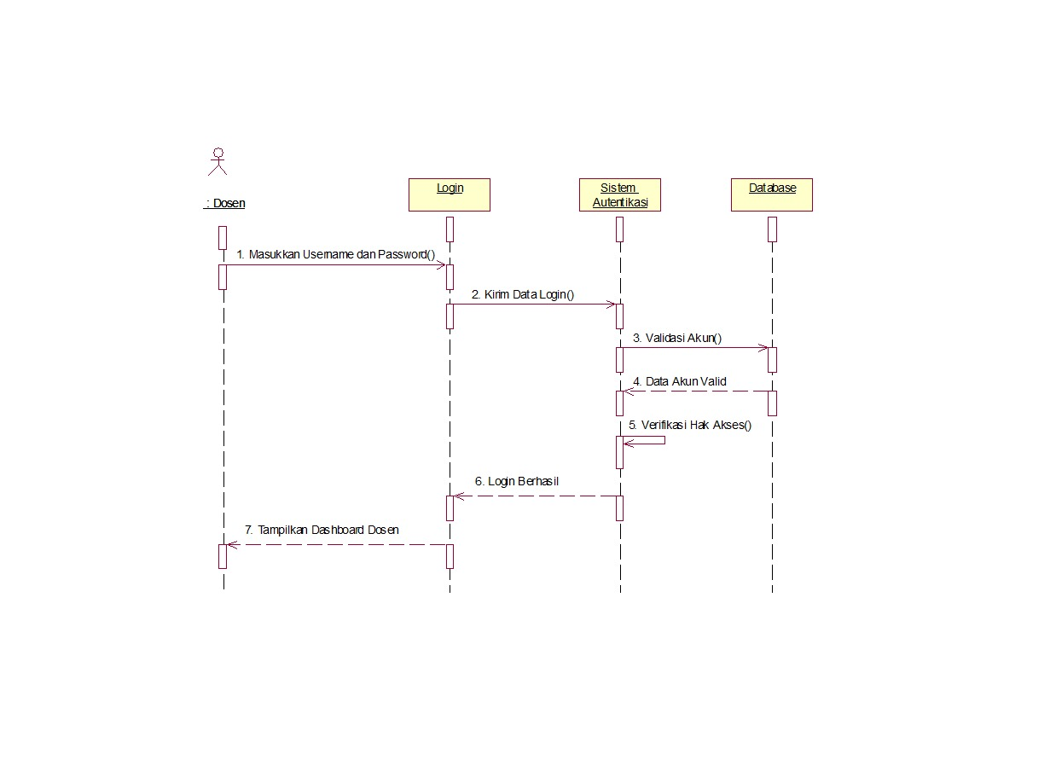

- Upload Tugas
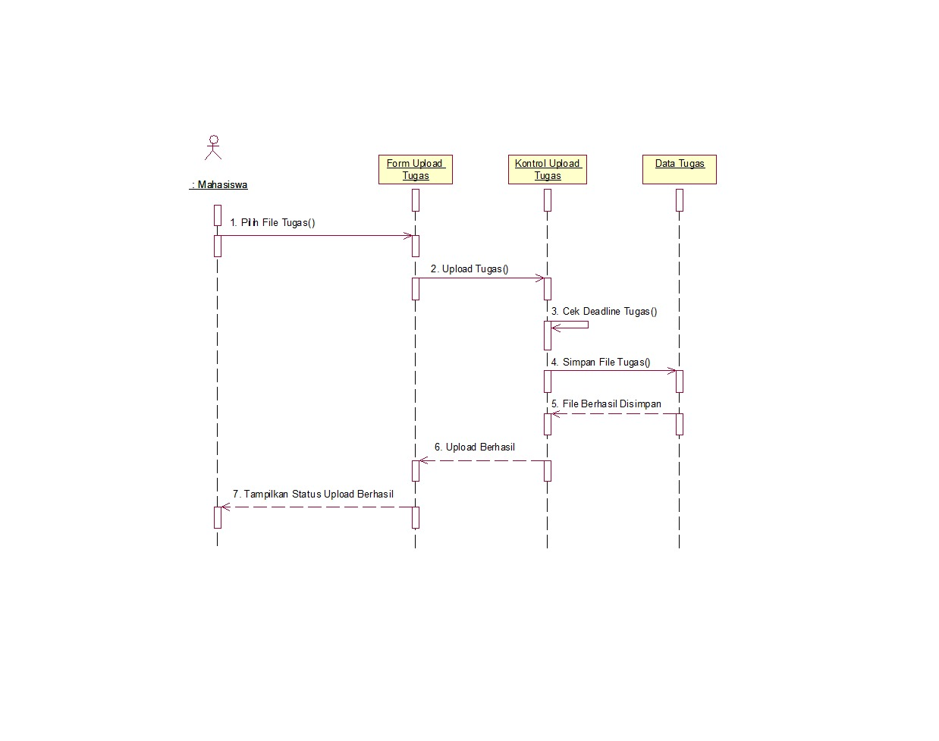

- Ajukan Sanggah Nilai

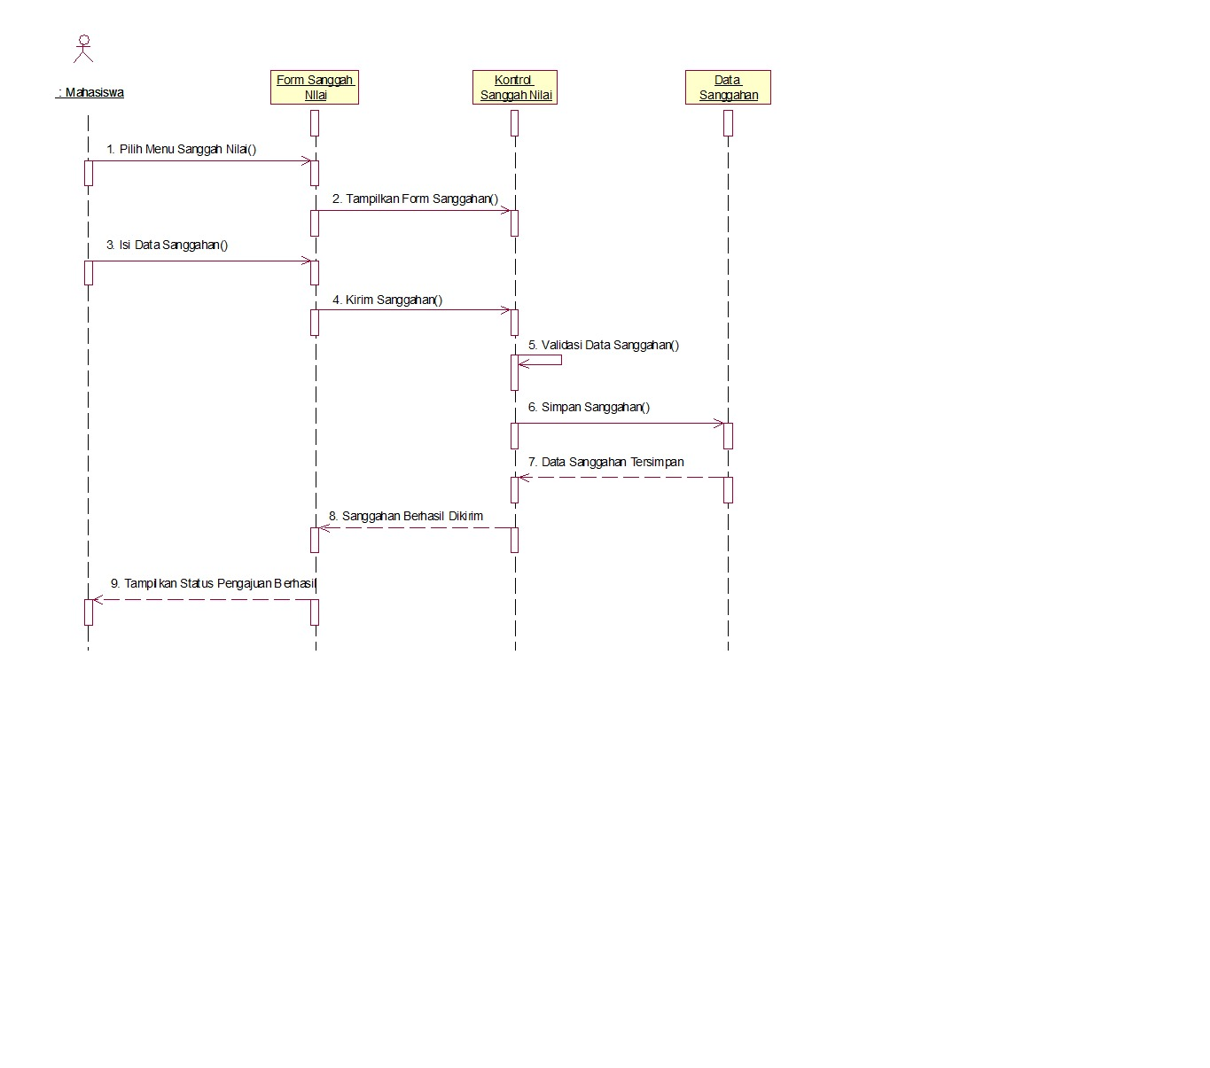

- COLLABORATION DIAGRAM

- Login Dosen
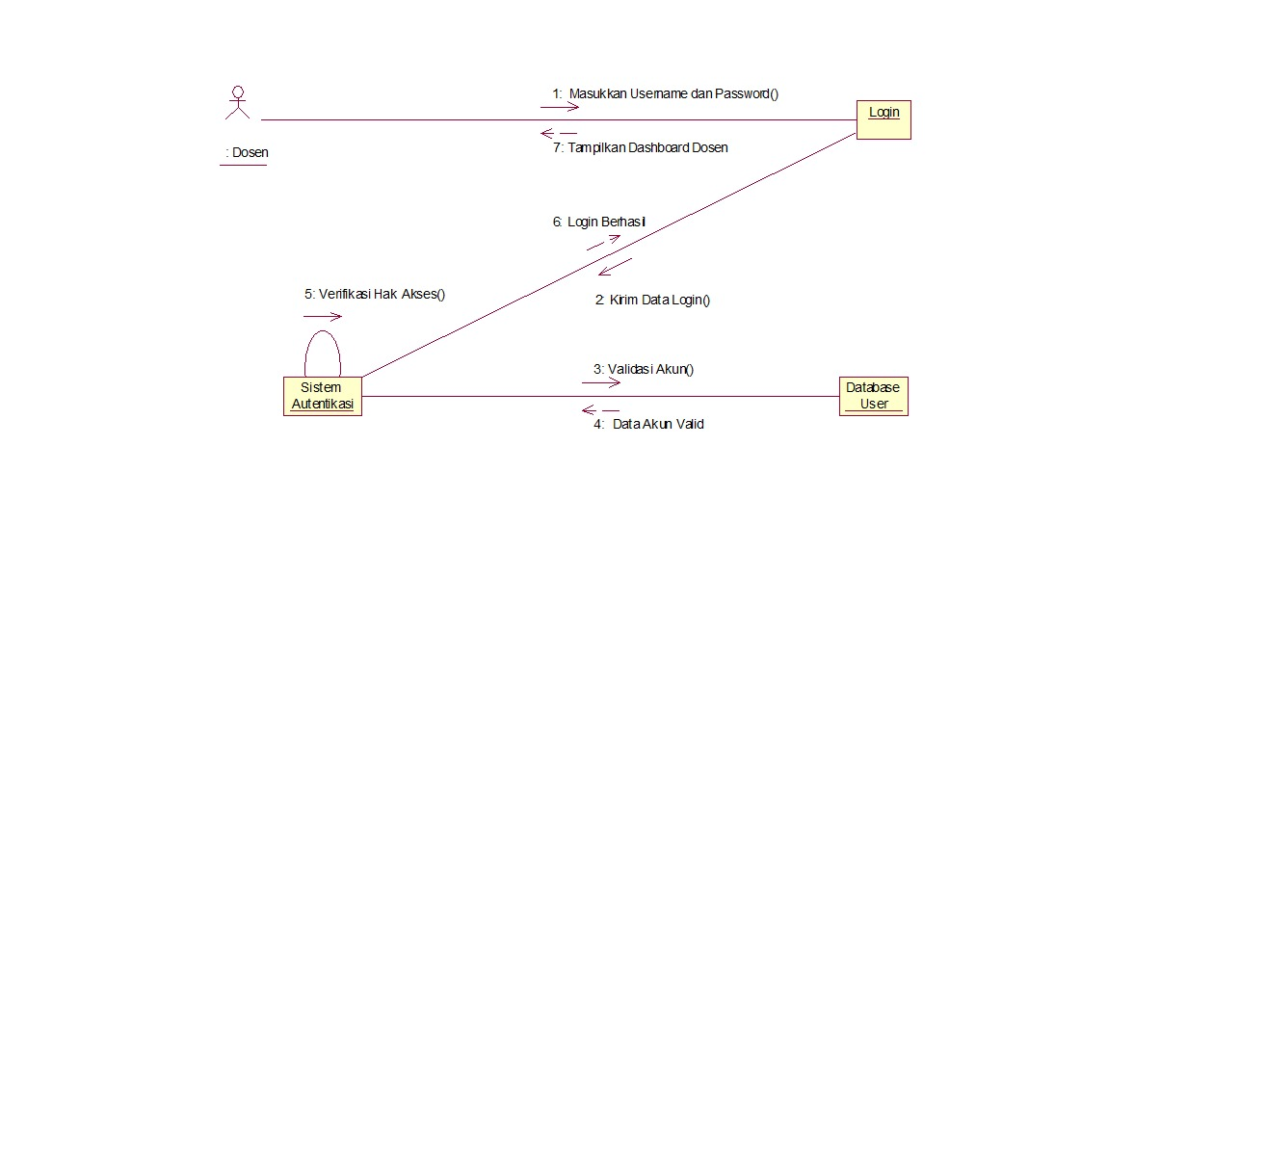

- Upload Tugas
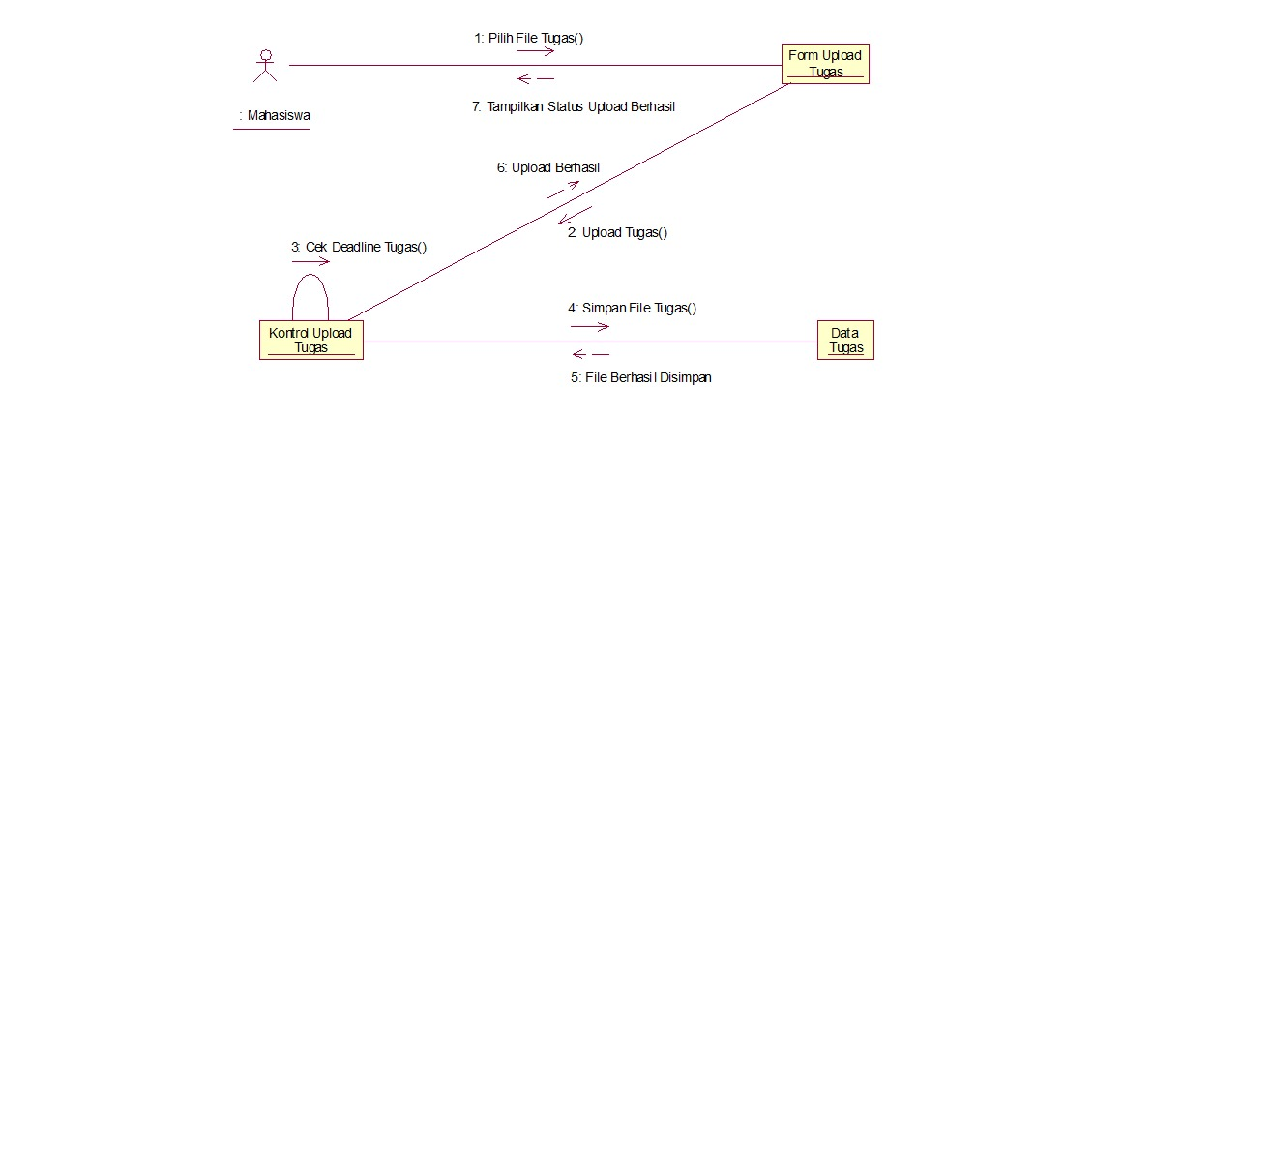

- Ajukan Sanggah Nilai
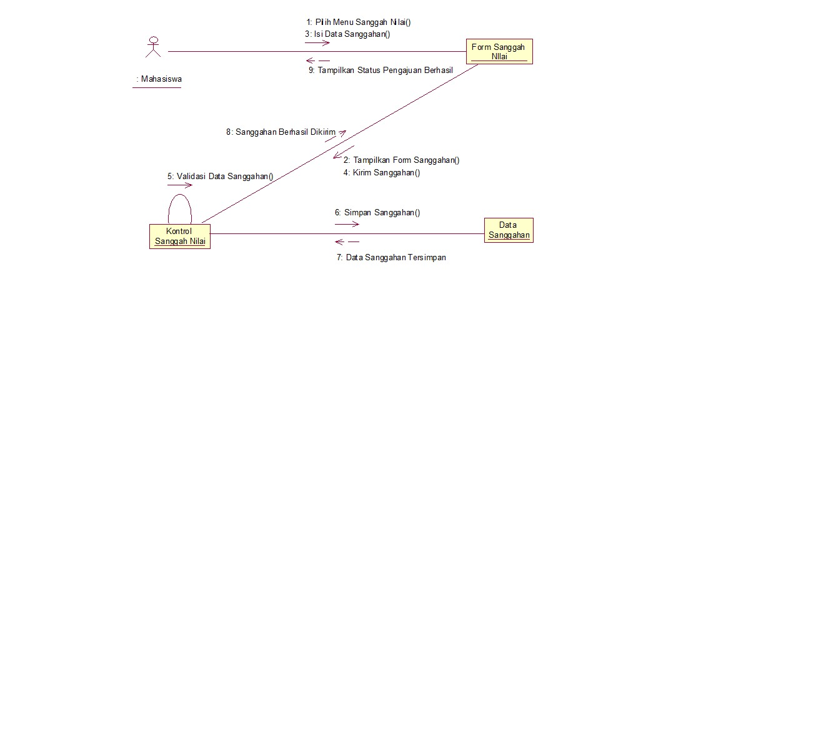

- ACTIVITY DIAGRAM

